**Concept selection**

1. **Defining the problem**

Research was conducted by the whole team at the beginning of the project to gain a powerful understanding of how a driver’s alertness level can be detected. This was the first crucial step which allowed us to then start the concept selection phase. A driver who is not fully alert is likely to be subject to drowsiness. Drowsiness is “a state of impaired awareness associated with a desire or inclination to sleep”[1]. It was therefore decided that our solution should both detect if the driver is drowsy, for prevention, as well as identify if he has fallen asleep, to wake him up.

We then had to find how sleepiness can affect a user’s driving. We found that monitoring drowsiness can be grouped into 3 major categories[2]:

* Vehicle based measures: through looking at unwanted deviations from lane position, steering wheel patterns or pressure variation on the acceleration pedal.
* Behavioural measures: by detecting yawning, eye closure, eye blinking, and head pose with respect to the headrest.
* Physiological measures: by monitoring heartbeat, muscle contractions, and the cornea-retinal standing potential of the eyes or cerebral activity.

Once it was clear what possible options were opened to us, we started the concept selection process.

1. **Competitor analysis**

The first task was to identify if and which similar products had already been implemented, to ensure our solution was innovative and could compete with existing ones. The key players of Advanced Driver-Assistance Systems (ADAS) can be separated into the aftermarket and its embedded categories.

Aftermarket solutions:

* **Mobileye**: this device, created by Intel, records the road environment surrounding the car to identify potential collisions and warn the user with an alarm and visual indicators. However, it cannot detect drowsiness and is extremely expensive (1049€, price not available in pounds)[3].
* **Anti-Sleep-Pilot**: a Danish invention that measures the driver’s reaction time with multiple tests, as well as the time spent driving to anticipate sleepiness[4].

Surprisingly, the number of available commercialised aftermarket solutions is limited. Although there are a lot of prototypes for this kind of application, most finalised solutions are ones embedded in cars.

Embedded solutions:

These solutions were not considered as direct competitors, as an embedded solution is not one that can be moved from one vehicle to another and cannot be bought separately from the vehicle. Instead, studying these solutions was made in order to discover more ideas of how we could solve the problem we faced.

* **Active Driving Assistant** (BMW): analyses driving behaviour and, if necessary, advises the driver to rest. The advice to take a break is provided in the form of graphic symbols shown on the Control Display.
* **Driver Drowsiness Detection** (Bosch): takes input from the steering angle sensor, front-mounted lane assist camera, vehicle speed and turn signal stalk.

Multiple other embedded solutions exist and can be found in the Reference section[5].

1. **Detection method**

Following the competitor analysis, several monitoring concepts were considered to detect drowsiness in real time.

**• Steering Wheel**

An alert driver will continuously perform micro-corrections in steering wheel movements to maintain an optimal position on the road. Once the driver is drowsy, such corrections disappear, and falling asleep can result in either no movement or sudden movements. Position sensors would therefore be installed on the steering wheel. They would either be directly wired to the input of the main processing board or send wirelessly their monitored data. The first case could be easy to implement but would be unappealing for the user. The second case would require an external power source to the position sensors, such as batteries, which would make the monitoring system bigger and might hinder the user’s driving. Embedded sensors in the steering wheel would require the user to manually open the steering wheel, and is therefore not an option.

**• Facial monitoring**

Using a camera and computer vision, the idea would be to detect eyes blinking frequency or eyes closing as well as yawning. That way, we could both detect drowsiness and see if the driver has fallen asleep almost instantaneously. However, this requires fast, expensive hardware and advanced technological knowledge in computer vision.

**• Body electrical signals**

Use an electrocardiogram, electromyogram or electroencephalogram to detect early a correlation between electrical signals (heartrate/cerebral activity/muscle contraction) and sleepiness. Though a probably reliable method, this would require the user to wear such monitors which might create discomfort.

**• Pedal**

This concept would use pressure sensors on the car’s pedal, to detect sudden changes in acceleration. Again, wiring it to a processing board would lead to an unappealing or uncomfortable solution.

**• Lane monitoring**

Look at unexpected road changes and slow lane deviation, as well as possible object collision. This solution is technologically advanced and was already implemented with **Mobileye** by Intel, so we would also need to add extra features. Nevertheless, its downside is that it cannot detect if the driver has fallen asleep.

**• Concept Selection Table**

|  |  |  |  |  |  |
| --- | --- | --- | --- | --- | --- |
| **Criteria** | **Steering Wheel** | **Facial monitoring** | **Body electrical signals** | **Pedal** | **Lane monitoring** |
| Safety | - | + | + | - | + |
| Accuracy | avg. | + | + | - | avg. |
| Cost | + | avg. | avg. | + | avg. |
| Comfort level | - | + | - | - | + |
| Complexity | + | - | - | avg. | - |
| Robustness | - | avg. | avg. | - | avg. |
| Net Score | -1 | +2 | 0 | -3 | +1 |
| Decision | x | √ | x | x | x |

Here each concept is analysed from six different perspectives, the score for each being given by good (+), average (avg.) or bad (-). The concept with the highest score, the **facial monitoring device**, was selected.

1. **A music-playing mobile application**

As an extra feature, it was decided that a mobile application would be realized. Two major operating systems were opened to us: Google’s Android and Apple’s iOS. Android is a Linux based OS, offering more hardware flexibility and customizable features. On the other hand, iOS is better regarding privacy control. As we record the driver’s face, privacy and information safety are a crucial aspect to consider (see Ethical report in “Conclusions” document), which is why the group chose to develop the application on iOS using the Swift environment.

Once the driver has fallen asleep, a music pre-selected by the user would be played to prevent him from sleeping again in the following minutes, giving him time to take a rest. This is a strong commercial argument, as it provides a more user-friendly approach to the use of our solution. However, the application would not be necessary for the device to work: That way, even if the user forgot his phone or does not have an iPhone, he could still get the security benefits of our device. The team then had to choose the appropriate components.

1. **Components**
2. BOARD

The first major component to choose was the processing board, as the whole prototype was to be built around it. The requirements for the board were that it should have an embedded camera or camera interface for the computer vision algorithm, as well as Bluetooth communication or the possibility to add a Bluetooth extensive board, to connect to the mobile application.

Also, as we planned to use real-time image processing for the drowsiness detection, boards with at a least a 32-bits architecture and a high memory were preferred. Finally, boards with a screen would stand out as a better user-friendly option. Following these criteria, the STM32F746G Discovery board was initially chosen (see Figure 1).

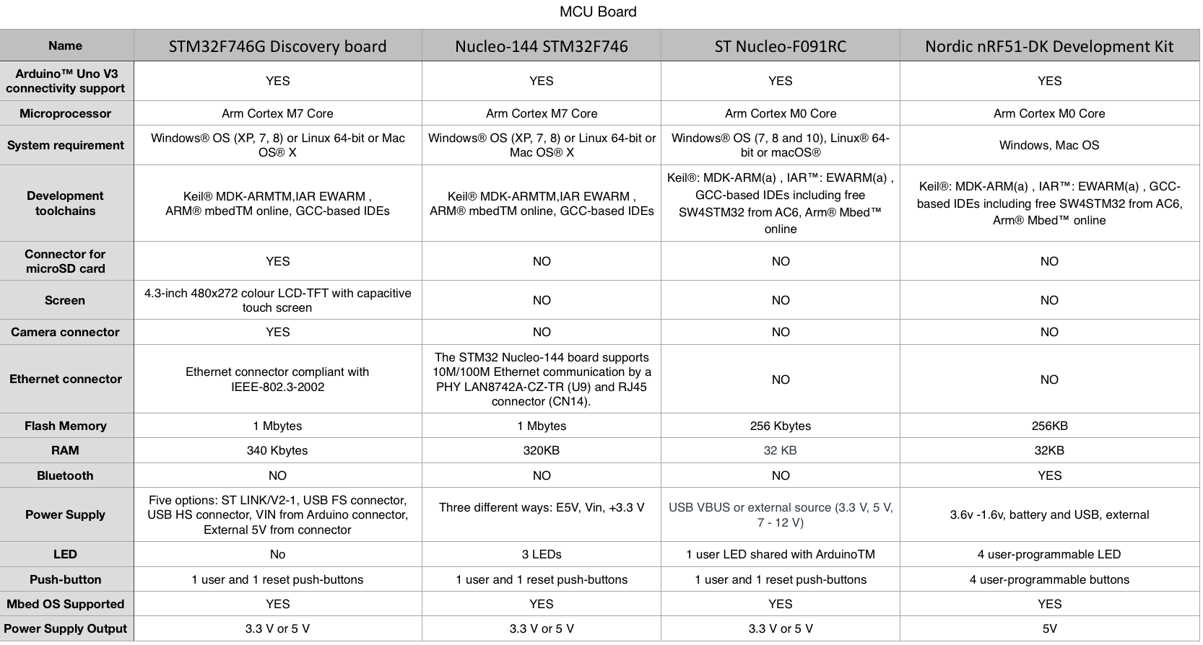

Figure 1: Analysis of several ARM boards

However, after discussing with our Client, it was decided that an infrared camera was a compulsory component to use, and a normal camera would not suffice. The reasoning behind this decision was that drowsiness can most likely happen at night, and we wanted our device to also work in the dark, which is available only with infrared lenses. There wasn’t any available infrared camera for the Discovery board, so the team finally dropped this microcontroller solution.

Initially not considered as it was not an ARM board, the Raspberry Pi 3 Model B+ was finally chosen (see Figure 2). It is a low-cost, versatile, easy to program single-board computer with a 4.2 Bluetooth Low Energy (BLE) module. It features a system on chip (SoC) with ARM compatible CPU (Cortex-A53, 64 bit) and GPU, with a camera interface that enables connection to a much wider range of cameras, including infrared ones.

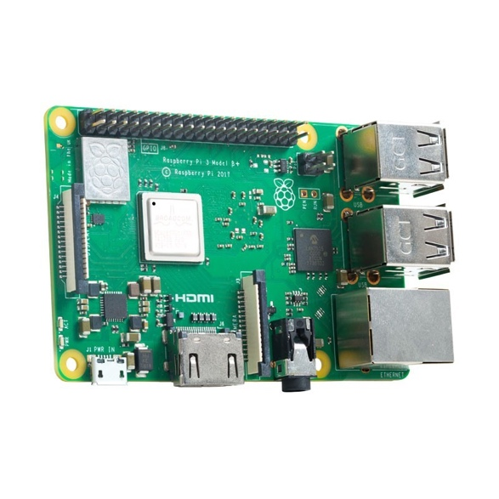

Figure 2: Raspberry Pi 3 Model B +

1. CAMERA

At the beginning, several cameras were considered to support the STM32F746G Discovery board (see Figure 3).

|  |  |  |  |  |  |
| --- | --- | --- | --- | --- | --- |
| **Part Number** | **Pixels** | **Sensor** | **Best Resolution** | **Dimension**  **(mm)** | **Feature** |
| OV5640 Camera Board (A) | 5M | OV5640 | QSXGA 2592x1944 | 35.7x23.9 | Cost effective |
| OV5640 Camera Board (B) | 5M | OV5640 | QSXGA 2592x1944 | 35.7x23.9 | Fisheye lens, 170 degree diagonal |
| OV5640 Camera Board (C) | 5M | OV5640 | QSXGA 2592x1944 | 35.7x23.9 | Auto focusing, onboard flash |
| OV2640 Camera Board | 2M | OV2640 | UXGA 1622x1200 | 35.7x23.9 | Lower price |
| OV9655 Camera Board | 1.3M | OV9655 | SXGA 1280x1024 | 35.7x23.9 | Lower price |
| OV7670 Camera Board (B) | 0.3M | OV7670 | VGA 640x480 | 35.2x34.3 | Cheap |

Figure 3: Cameras for STM32F746G Discovery board

With all prices being lower than £40, the cost was not an issue, and we could therefore focus on the camera’s images quality. Only the components A, B and C fulfilled this first criterion. Then, because a fisheye lens distorts pictures and might affect face detection, only camera A and C remained. Finally, as the distance from the device to the user will vary depending on how he installs it on his dashboard, an autofocus feature is desirable, making the OV5640 Camera Board (C) stand out. Hence, this model was first chosen as our vision component for the STM32F746G Discovery board.

However, the OV5640 Camera Board did not provide night vision and couldn’t connect to the Raspberry Pi. It was therefore abandoned. Instead, the Raspberry Pi HD Pi NoIR Camera Board V2 was chosen (see Figure 4). Being the only one developed by the Raspberry Pi Foundation with an infrared camera, this offered an easy interface with our board as well as all the features we were looking for:

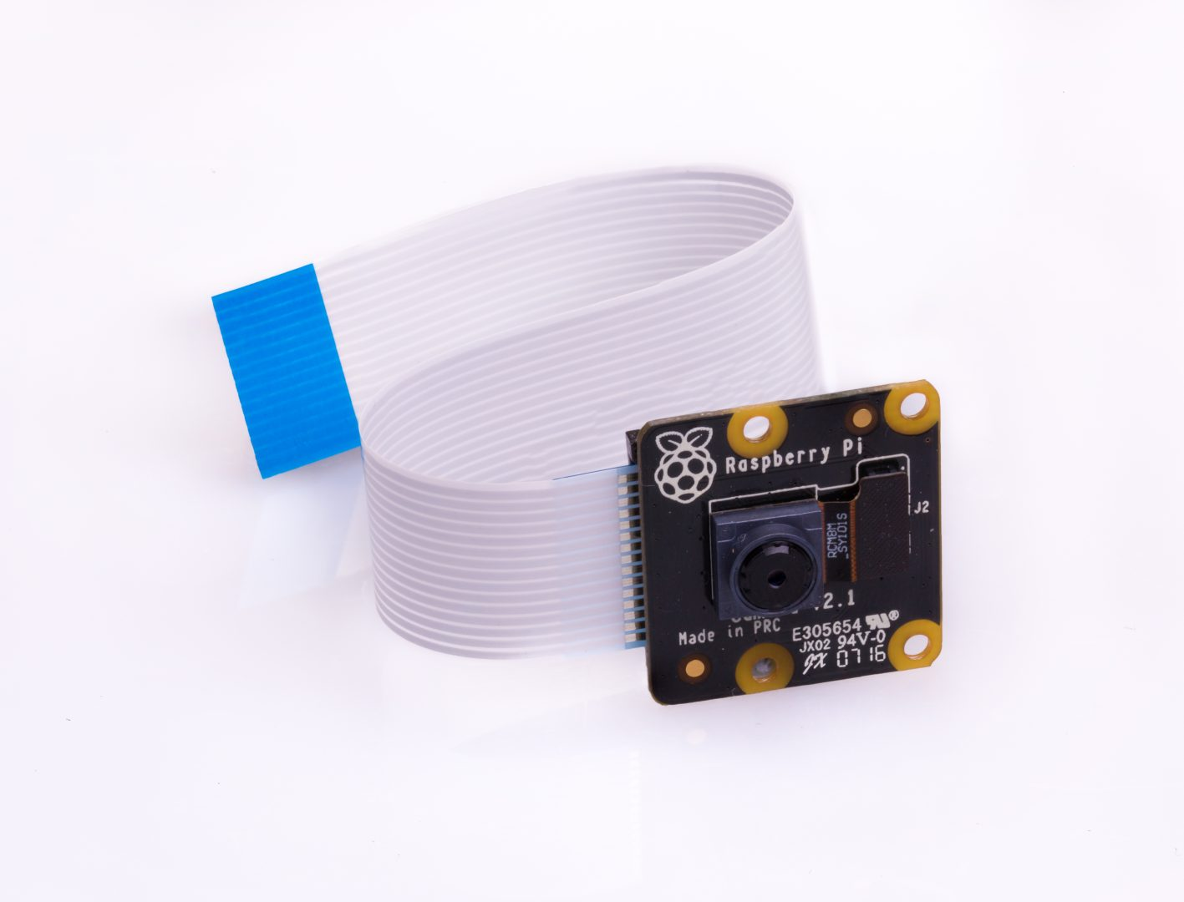

Figure 4: PI NOIR CAMERA V2

* No IR filter (enables night vision)
* High-quality imagery
* High data capability
* 8 megapixels fixed focus
* Supports 1080p, 720p60 & VGA90
* Sony IMX219PQ CMOS image sensor
* 15-pin ribbon cable

1. EXTENSION BOARD

Certain features we wanted to include were not directly offered from our main processing board. When we started looking at the Discovery board that did not have a Bluetooth module, we had to find an appropriate BLE extension board (see Figure 5).

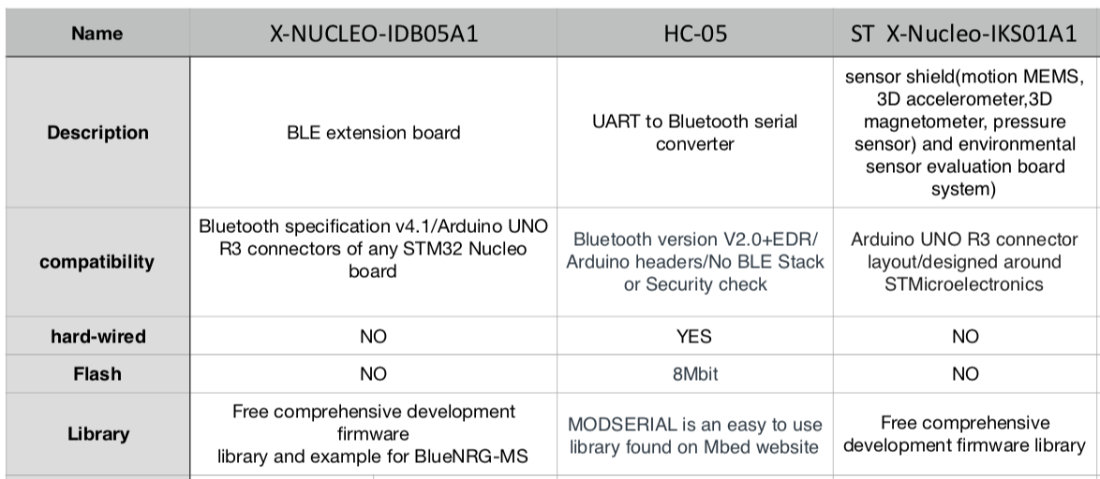

Figure 5: Bluetooth boards for the STM32F746G Discovery board

We only require from our board to send a signal to the App once the driver has fallen asleep. Therefore, we were looking for the most energy efficient one. Speed wasn’t an important factor here, as the device would first wake up the user with an alarm (which should be instantaneous), and then the music would be played. Extra functionalities were not of much use, and neither was flash memory, so we discarded the HC-05 and ST X-Nucleo-IKS01A1 boards, to keep the simple but efficient X-NUCLEO-IDB05A1 one. If steering wheel patterns were to be also monitored, the IKS01A1 would have been a better option, since it includes a sensor shield.

For the Raspberry Pi, there was no need for such add-on board, since the Bluetooth functionality was embedded. However, to warn the user of his drowsiness or if he has fallen asleep, the team decided to provide visual and acoustic warnings via LEDs and a buzzer. An appropriate extensive board was found to be the Traffic HAT (see Figure 6). It includes 3 LEDs of different colours, one buzzer and one programmable button, which enabled us to add extra functionalities if time allowed it. Cost-effective, easy to program and easy to mount on the Raspberry Pi, it was therefore chosen in the final prototype.

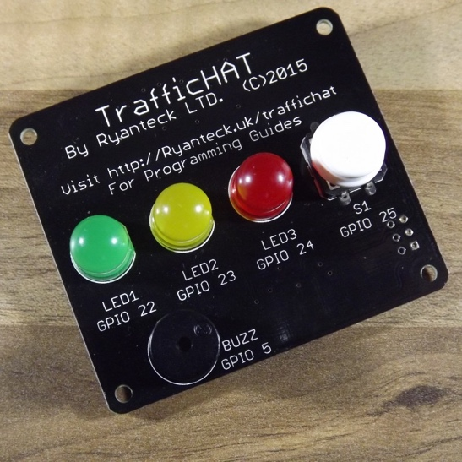

Figure 6: Traffic HAT board

1. **CASE DESIGN**

The group looked at multiple case options to optimise the aesthetic design and the positioning of the camera with respect to the user’s face. The requirements set were the following:

* The case should be able to cover both the Raspberry Pi and the Traffic HAT mounted on top of it.
* The camera angle could be modified to the user’s preference, as dashboards vary from car to car, and user’s height will usually vary. The aim of this is to be able to always have the camera aiming as straight as possible at the driver’s face.
* The customer should be able to easily see the lights of the Traffic HAT, without having to turn his head.

Possible solutions were found on the internet:

* **Pi Camera Box Bundle**[6] from ModMyPi (see Figure 7). The driver adjusts the camera angle using thumb screws.

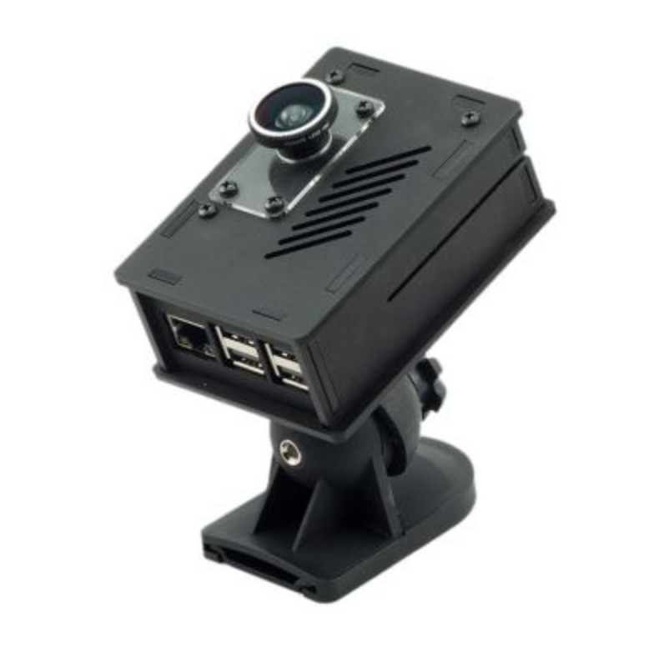

Figure 7: Pi Camera Box Bundle

*Features:*

|  |  |
| --- | --- |
| **Dimensions** | 101mm x 70mm x 33.3mm |
| **Colour** | Black matte acrylic |
| **Thickness of case** | 3mm |
| **Tilt angle** | -24° to +15° |
| **Swivel angle** | ~75° left and right |
| **Price** | £23.99 |

Problem

The freedom in angle rotation is limited, especially for a vertical adjustment. Additionally, the ventilation holes on the top of the case do not permit a good perception of the LEDs, and the Traffic HAT being wider than the Raspberry Pi, the case wouldn’t properly fit. Therefore, this case was discarded.

* **Dev Board Enclosure**[7] from MULTICOMP (see Figure 8).

This case fits both boards, as well as the camera. The transparent glass enables colour readings, which wasn’t available with the previous case.

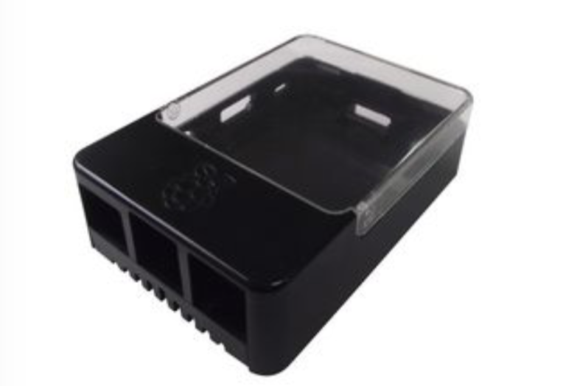

Figure 8: Dev Board Enclosure

*Features:*

|  |  |
| --- | --- |
| **Dimensions** | 26.6mm x 63.9mm x 93.5mm |
| **Colour** | Black ABS, Polycarbonate |
| **Price** | £5.99 |

Problem

The group decided not to use this case because it does not have a camera case with it, so the camera module is left outside the case. As the ribbons connecting the camera to the board are flexible, it would have been very hard to maintain the camera module in a fixed position, which is undesirable.

* **3D-printed case** (see Figure 9).

Because no members of the team had any experience in 3D printing, this solution was not immediately chosen. However, it remained the only option that could enable us to choose the perfect dimensions for the prototype, meeting all of the case requirements, as well as giving our personal design touch. For these reasons, we eventually used a 3D-printed case.

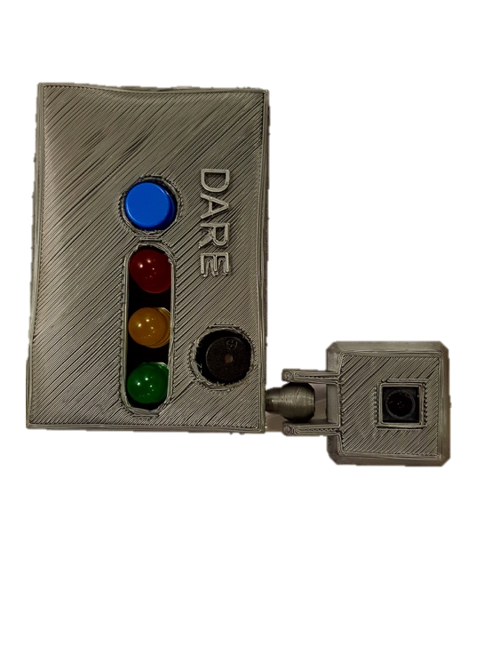

Figure 9: 3D-printed case

1. **SPLITTING THE TASKS**

Once the final prototype concept was chosen, sub-teams were allocated to perform the various tasks that were required for the project as follows (see Figure 10).

* **Software**

**Valentin**: Face detection and drowsiness detection algorithms, leaflet, poster, dashboard, split tasks, arrange meetings.

**Martin**: Face detection and drowsiness detection algorithms, documentation (user manual, decision taken, design history, material sourced and used, testing).

**Wenjia**: IOS app interface design and algorithm development, Bluetooth, documentation (ethical consequences, sustainability).

**Edward**: Bluetooth communication, documentation (user manual, decision taken, design history, material sourced and used, testing).

* **Hardware**

**Kexin**: 3D Printing case, high level interface sketch, Gantt chart, milestones, documentation (project plan, 3D printing case design history, group meeting records, decision taken of online cases and 3D case).

* **Commercial**

**Lillian**: Leaflet, team purchase, video, documentation (specifications, market research).

Figure 10: Task allocations

Project

Software

Face Recognition

Valentin (team leader)

Martin

App and

Bluetooth

Wenjia

Edward

Hardware

Kexin

Commercial

Lillian

References

*[1] TheFreeDictionary.com. (n.d.). drowsiness. [online] Available at: https://medical-dictionary.thefreedictionary.com/drowsiness [Accessed 27 Jun. 2018].*

*[2] Sahayadhas, A., Sundaraj, K. and Murugappan, M. (2012). Detecting Driver Drowsiness Based on Sensors: A Review. Sensors, 12(12), pp.16937-16953.*

*[3] Mobileye. (n.d.). Mobileye 5 Series | Mobileye. [online] Available at: https://www.mobileye.com/en-uk/products/mobileye-5-series/ [Accessed 27 Jun. 2018].*

*[4] Lifewire. (n.d.). Worried About Falling Asleep While Driving? There's an App for That. [online] Available at: https://www.lifewire.com/anti-sleep-pilot-drowsy-driving-app-1999940 [Accessed 27 Jun. 2018].*

*[5] En.wikipedia.org. (n.d.). Driver drowsiness detection. [online] Available at: https://en.wikipedia.org/wiki/Driver_drowsiness_detection [Accessed 27 Jun. 2018].*

*[6] Modmypi.com. (n.d.). ModMyPi | ModMyPi - Pi Camera Box Bundle (Case, Lens & Wall Mount) - B+/2/3/3B+. [online] Available at: https://www.modmypi.com/raspberry-pi/cases-183/raspberry-pi-b-plus2-and-3-cases-1122/nwazet-pi-camera-box-bundle-case,-lens-and-wall-mount-b-plus [Accessed 27 Jun. 2018].*

*[7] farnell. (n.d.). [online] Available at: http://cpc.farnell.com/multicomp/cbpihat-blk/raspberry-pi-hat-enclosure/dp/SC14024?mckv=s2Ek5izBa_dm%7Cpcrid%7C224679642167%7Ckword%7C%7Cmatch%7C%7Cplid%7C%7Cpid%7CSC14024%7C&CMP=KNC-GUK-CPC-SHOPPING&gclid=Cj0KCQjw37fZBRD3ARIsAJihSr3_0HKSIZXzsPefFPQAGObQ9awve9o4b7XxzeRhbL6cCfBQapWQ9WMaAkWDEALw_wcB [Accessed 27 Jun. 2018].*